**SMART WATER MANAGEMENT**

**Objective**

Utilizing water resources sustainably, sensibly, and through recycling are the core goals of smart water management.

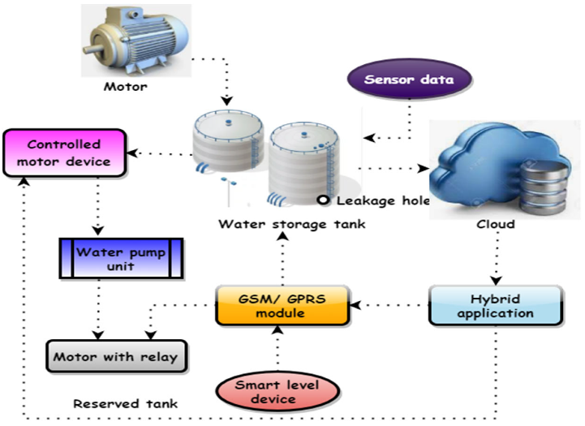**Setup Sensor**

**Mobile App Development**

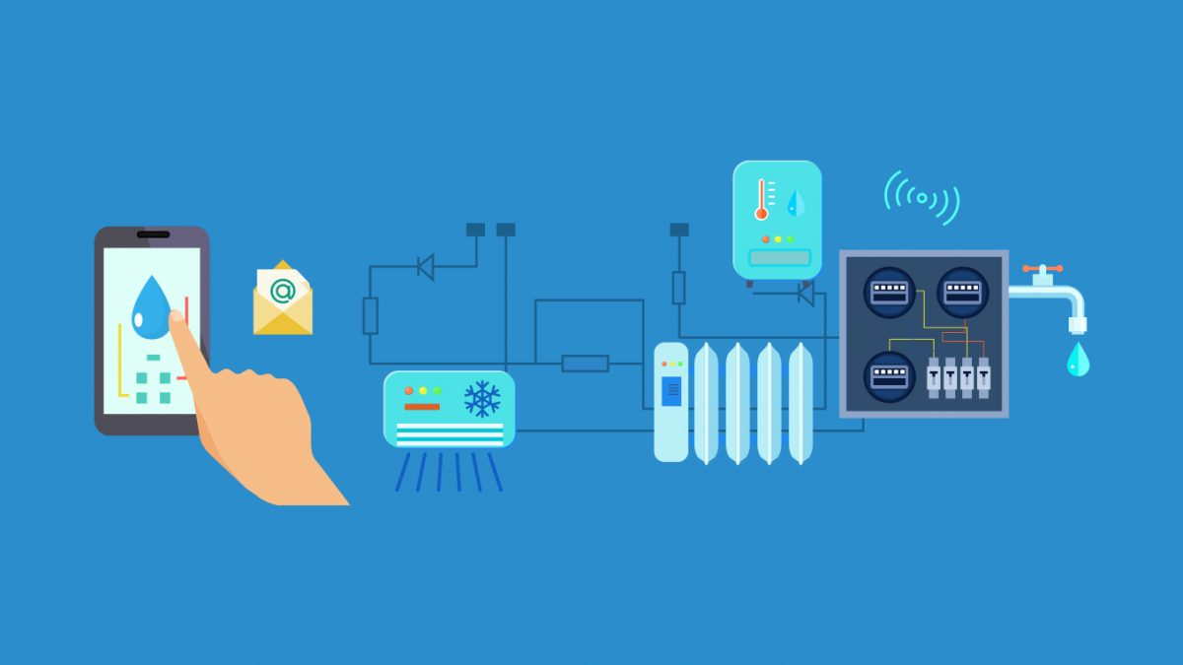

**Rasperi Pi Intergration**

The entire system relies on sensors that are connected to Raspberry Pis to keep an eye on the water supply and quality. The Raspberry Single Board Computer serves as the system's brain to carry out the intended operation**.**

**Coding**

from flask import Flask, render_template, request, jsonify

from flask_sqlalchemy import SQLAlchemy

from datetime import datetime

app = Flask(__name__)

app.config['SQLALCHEMY_DATABASE_URI'] = 'sqlite:///water_usage.db'

db = SQLAlchemy(app)

class WaterUsage(db.Model):

id = db.Column(db.Integer, primary_key=True)

timestamp = db.Column(db.DateTime, default=datetime.utcnow)

amount = db.Column(db.Float)

db.create_all()

def receive_water_data():

data = request.get_json()

if 'amount' in data:

new_water_usage = WaterUsage(amount=data['amount'])

db.session.add(new_water_usage)

db.session.commit()

return jsonify({"status": "success"})

else:

return jsonify({"status": "error", "message": "Invalid data format"}), 400

def get_water_data():

water_data = WaterUsage.query.all()

data = [{"timestamp": entry.timestamp, "amount": entry.amount} for entry in water_data]

return jsonify(data)

def home():

return render_template('index.html')

if __name__ == '__main__':

app.run(debug=True)

**App Screenshot**

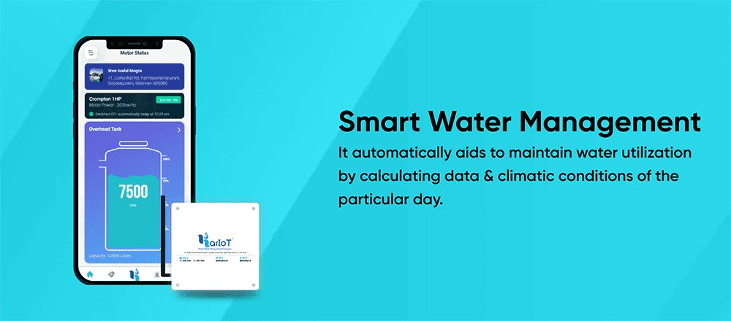

**Real Time Water Conservation Monitoring System**

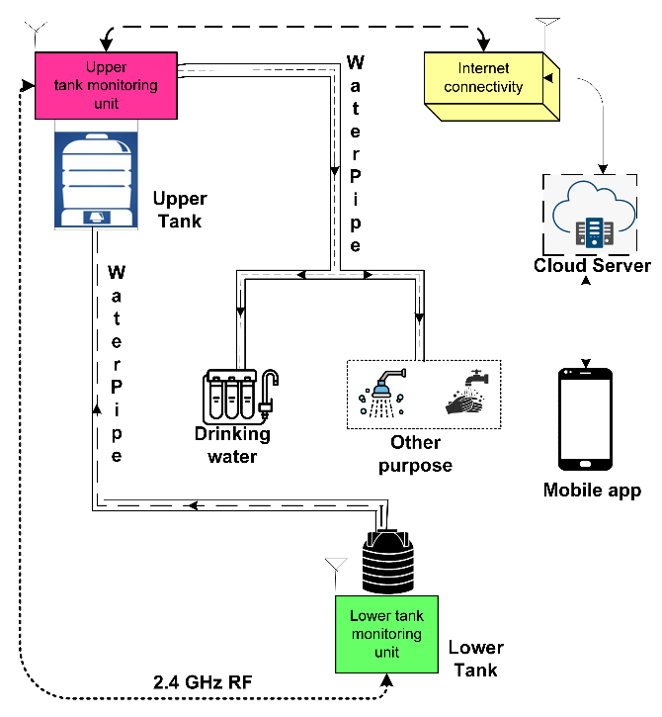Operators of water treatment facilities may be able to modify their treatment processes and more consistently satisfy regulations if they are given early warning of changes in the water quality at an intake. When environmental conditions are unsafe for aquatic life, recreational activities, or consumption, real-time monitoring can provide environmental alarms.

**Conclusions**

The proposed design, according to this system, becomes more autonomous with quick data transmission thanks to IOT. The fundamental benefit of IOT is that data may be transferred even when clients are not connected to the node network, and they can view the data that has already been delivered.

Water tank overflow can be reduced using smart water management, which can also provide real-time water usage in liters per hour. This system is reasonably priced. As a result, water may be used more effectively. Consequently, it decreases water waste. Using the outcomes of this project, this project can be improved even more. To determine the quality of the water in the tank, a turbidity sensor is installed.